Name & Period #
Title

??? Timeline

1.
3.
5.
7.
9.
2.
4.
6.
8.
10.

Insert Picture here Wrap Text “Send Behind Text” Drag up to Behind Timeline above.
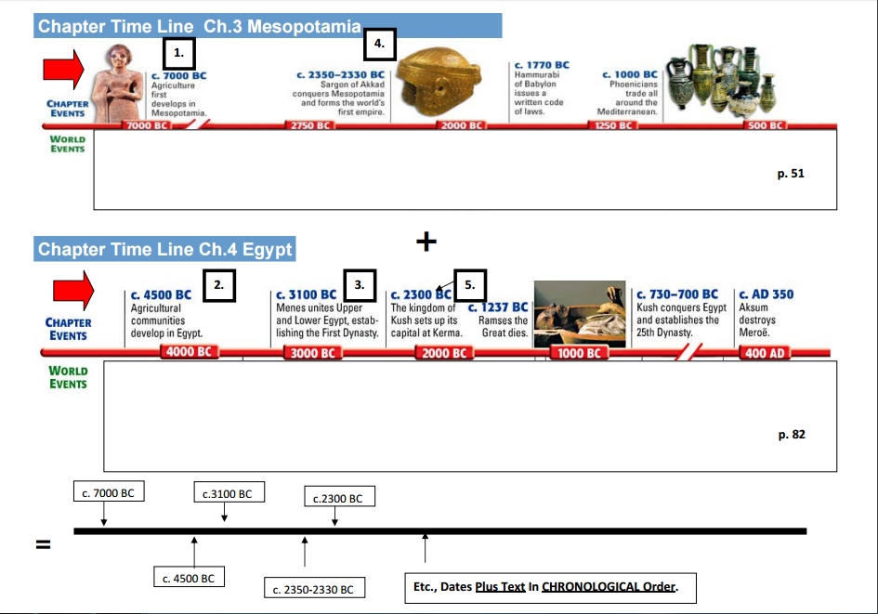

http://itasca.k12.il.us/peacock/6team/peel/timeline_projects/women/index.htm

http://itasca.k12.il.us/peacock/6team/peel/timeline_projects/african_american/index.htm

