Grandma’s C.E. TECH! © 2016 dPeel.com Name______________________________________ Period_____
* CAUSE EFFECT Quick Response HistoryClassRoom.com ShowYourClass.com

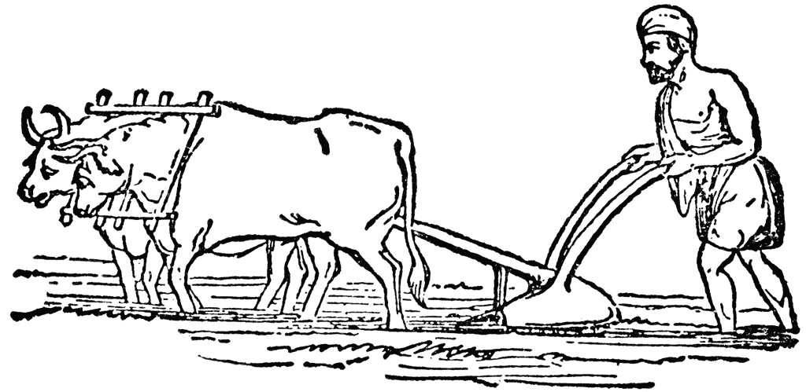
Agriculture Develops

EVENT
With QR Codes!
EVENT
---------------------------------------------------------------------------------------------------------------------------------------------------------------
On BACK
of This
Panel
Fold Back

---------------------------------------------------------------------------------------------------------------------------------------------------------------
Hunter-Gathers
Drop Seeds, Discover they grow where dropped.

World History Rocks!

CAUSE
CAUSE
---------------------------------------------------------------------------------------------------------------------------------------------------------------
Fold Back
On BACK
of This
Panel

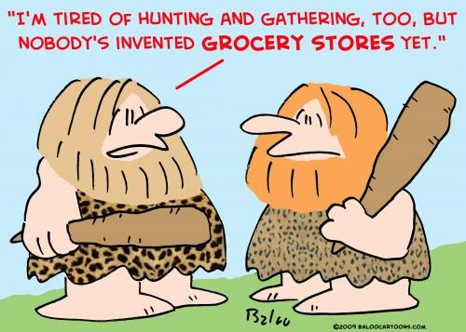
----------------------------------------------------------------------------------------------------------------------------------------------------------------
Early Man Settles in One Place.

Where’s Grandma?
EFFECT
EFFECT
----------------------------------------------------------------------------------------------------------------------------------------------------------------
Fold Back
On BACK
of This
Panel

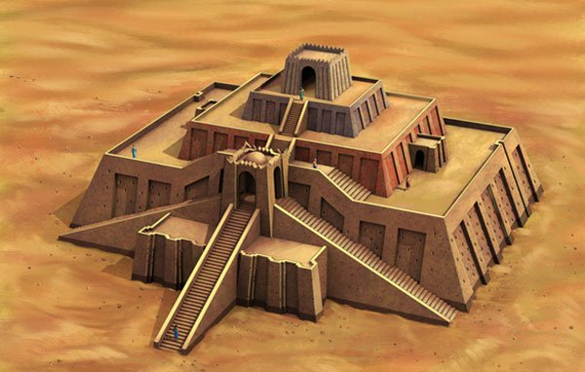
----------------------------------------------------------------------------------------------------------------------------------------------------------------
Towns grow, Civilization Develops.

Grandma’s
7UP PREZIS
SO WHAT?
SO WHAT?

