**Definition: Grandma’s *F.O.L.D. TECH* Chapter__ Definition:**

***F.O.L.D. TECH* (F.lexible O.nline L.earning D.evice)   
©2016 dPeel.com**



***Grandma’s 7UP PREZI* 🡪 “Rocks 2 Rock-N-Roll” YouTube Video Reviews, Main Ideas, Timelines, Key Terms, Audio Textbook – English & Spanish, Flash Cards & Where’s Grandma? “School House Rock” Videos for the Chapter!**



**Picture**

**Picture**

**Definition: Definition:**

**Picture**

**Picture**

**Word  Word**

***ROCKS 2 ROCK-N’-ROLL* Video Reviews!**

**F.O.L.D. TECH (F.lexible O.nline L.earning D.evice) ©2016 dPeel.com**

**Rocks 2 Rock-N-Roll Review Grandma’s Review**

**Grandma’s *F.O.L.D. TECH!*    
  
  
Name__________________________ Period____**

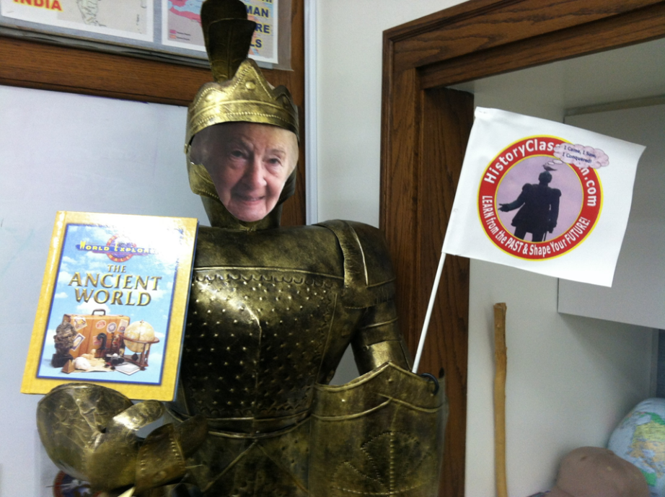

**Word Word**